====Bomb defusal manual (V.0.3.2)====
In front of your partner currently is a ticking time bomb – literally. Your job using this document is to figure out the sequence of inputs required to disarm it.

Modules:
The bomb is made of 3 important modules, each will need to be disabled before the disarm button is hit.

Timer:
You have around 3 minutes to defuse the bomb. Failure to complete a module (e.g. cutting the wrong wire, will cause the timer to instant.

The different modules of the bomb are explained in this document.

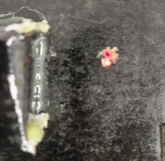
Seed LED:
Figure 1: Seed LED
Three versions of the bomb exist.
The one in front of you has an
indicator in the top right corner
illustrated in figure 1 here.

From now on, each bomb will be given a different name, RED BOMB, GREEN BOMB, BLUE BOMB

Defusal Button:
The big red button should ONLY be pressed once you are positive all three modules are defused.
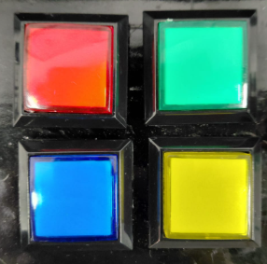
Simon Says:
The four colored buttons are
part of a Simon says game.
Below is the button order
needed to be pressed to defuse
this module:

Red Game:
Figure 2: Simon Says Buttons
Start with red (1), head to its right (2).
Venture down (3), then go back to the beginning (4)
Go Blue! Go Blue! Go Blue! (5) (6) (7)

Green Game:
Figure 3: Simon Says Buttons
Go through your _ _ _ display, in order (1) (2) (3)
Press the right button, the only one left (4)
Going from Red to Yellow, press three going right then down (5) (6) (7)

Blue Game:
Four days I feel blue. (1) (2) (3) (4)
This lazy explanation makes me angry; GRR!!! (5) (6) (7)

Cut the Wire:
Three colored wires lie at the bottom of the box. Two need to be cut but be careful; cutting the wrong one will result in an immediate explosion.
The first wire to be cut on any version of the game, will always match the color of your Seed
(with the blue seed cutting the brown wire)

The table below shows the rest (see footnote):
Red Game | Green Game | Blue Game
Brown Wire | Red Wire | Red Wire
(PLEASE NOTE that due to a printing error the colors of the text is the color that should be followed when cutting, COE421.inc is not responsible or liable for any mishaps injuries or deaths caused by a misunderstanding of this very easy to read warning)



Figure 4: This section down here was written by Hamad Siddiqi

KeyPad Quiz:
Answer the questions below by typing out your answer on the keypad, make sure you answer the questions in order. Any wrong press of a button and the bomb explodes.
(DO NOT PRESS * OR # AFTER AN ANSWER)

Below is the mapping from keypad keys to the Alphanumeric options:
1 | 2 | 3 | A
4 | 5 | 6 | B
7 | 8 | 9 | C
* | 0 | # | D
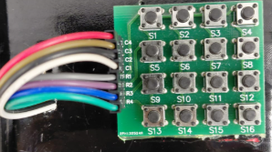

Question 1:
Which year did France last win the world cup? (4 digits)

Question 1:
How many credits are in the new AUS Computer Engineering Catalog? (3 digits)

Question 1:
Where is professor Khaldouns office located?
(EB2 _ _ _ , 3 digits)

Question 2:
What grade are Hasan Morobeid, Sam Tom, Hamad Siddiqi, and Omar Hamzeh getting on the Computer Systems Engineering Lab? (Enter one Letter Grade)

Good Luck,
Best.

